**Face Recognition Based Attendance System**

**MD MUSHARRUF - 20R21A0598**  
Computer Science and Engineering  
MLR Institute of TechnologyHyderabad, India

**N DURGA SAI - 20R21A05A0**  
Computer Science and Engineering  
MLR Institute of TechnologyHyderabad, India

**N DHANUSH REDDY - 20R21A0599**Computer Science and Engineering  
MLR Institute of TechnologyHyderabad, India

**B MAHESH - 20R21A0566**  
Computer Science and Engineering  
MLR Institute of TechnologyHyderabad, India

**M ADARSH - 20R21A0590**  
Computer Science and Engineering  
MLR Institute Of TechnologyHyderabad, India

**Abstract**

We are living in a world where everything is automated and linked online. The internet of things, image processing, and machine learning are evolving day by day. Many systems have been completely changed due to this evolve to achieve more accurate results. The attendance system is a typical example of this transition, starting from the traditional signature on a paper sheet to face recognition. This Project proposes a method of developing a comprehensive embedded class attendance system using facial recognition with showing whether the face of the person is the student for that specified class or not. The system is based on the machine learning algorithm which is to be implemented on python language and using computer/laptop camera for the input image of the students or a normal outer camera can also be used which has to be connected to the system which is programmed to handle the face recognition by implementing the Local Binary Patterns algorithm LBPs.

Keywords -

# **Introduction**

Traditional method of attendance marking is a tedious task in many schools and colleges. It is also an extra burden to the faculties who should mark attendance by manually calling the names of students which might take about 5 minutes of entire session. This is time consuming. There are some chances of proxy attendance. Therefore, many institutes started deploying many other techniques for recording attendance like use of Radio Frequency Identification (RFID), iris recognition, fingerprint recognition, and so on. However, these systems are queue based which might consume more time and are intrusive in nature. Face recognition has set an important biometric feature, which can be easily acquirable and is non-intrusive. Face Recognition Based systems are relatively oblivious to various facial expression. Face recognition system consists of two categories: verification and face identification. Face verification is a 1:1 matching process, it compares face image against the template face images and whereas is an 1N problems that compares a query face images.

# **Literature survey**

Several models are proposed for automated attendance system. One of the models focuses on

how face recognition incorporated with Radio Frequency Identification (RFID) detect the authorized students and counts as they get in and get out form the classroom. In Another model authors have designed and implemented an attendance system which uses iris biometrics. This system automatically takes class attendance by capturing the eye image of each attendee, recognizing their iris, and searching for a match in the created database. The prototype was web based.In another model, It is proposed an attendance system based on facial recognition. The algorithms like Viola-Jones and Histogram of Oriented Gradients (HOG) features along with Support Vector Machine (SVM) classifier were used to implement the system. In further, researchers get best facial recognition algorithm (Eigenface and Fisherface) provided by the Open CV 2.4.8 by comparing the Receiver Operating Characteristics (ROC) curve and then implemented it in the attendance system. Based on the experiments carried out in this paper, the ROC curve proved that, Eigenface achieves better result than Fisherface. System implemented using Eigenface algorithm achieved an accuracy rate of 70% to 90%.

Later, an affine transformation is computed to perform the warping. Active shape models are used in to align input faces with model faces. A semi-automatic alignment step in combination with support vector machines classification was proposed in. An alternative to the global approach is to classify local facial components. The main idea ofcomponent based recognition is to compensate for pose changes by allowing a flexible geometrical relation between the components in the classification stage. In facerecognition It was performed by independently matching templates of a geometrical model of a face was implemented by a 2D elastic graph.

# **Existing system**

In the last twenty years, the computer-based facial recognition field has expanded rapidly. Several algorithms have been introduced and improved to the point where computers can rival humans in accuracy of facial recognition.

one of the Algorithm used in face recognition is viola jones. Viola-Jones algorithm is a machine-learning technique for object detection. first detect smaller features of a human face in that image and if all of those features are found then the algorithm predicts that there is a face in that image or sub-image.

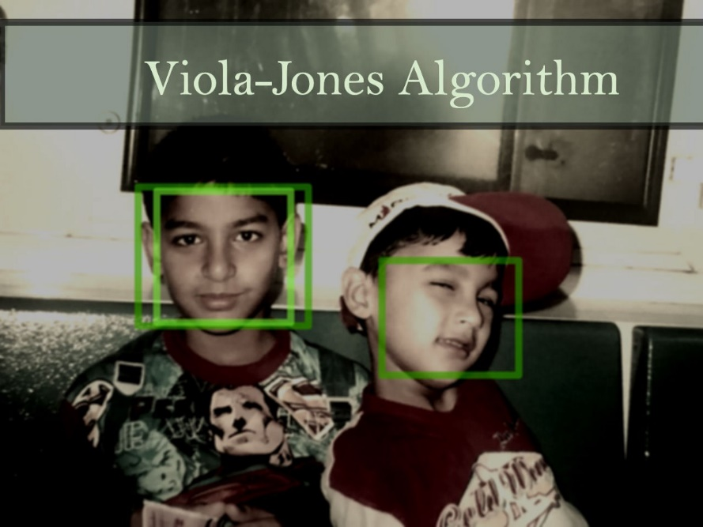

Fig 1: Images gets scanned for recognition.

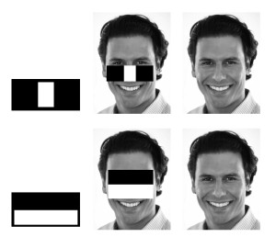

Fig 2: detection of features of a human face.

**Disadvantages of EXISTING system:**

1) The image quality of scanning video is quite low compared with that of a digital camera

2)The relative angle of the target’s face influences the recognition score profoundly.

3) Most algorithms allow specifications of a face-size ran

# **Proposed system**

The proposed methodology starts with the registration of students into the system. Following methodology has few main stages such as capturing images, pre-processing of the images, Haar Cascade classifier is used for face detection, developing a dataset of images, the further process of face recognition is done with the help of LBPH algorithm.

In our proposing system we are using opencv, Face Recognition libraries.

Libraries: OpenCV Haar Cascade Face Detection, Dlib HOG Face Detection, Face Recognition.

# **ADVANTAGES OF PROPOSED SYSTEM:**

1)Provides a valuable attendance service for both teachers and students.

2)Reduce manual process errors by provide automated and a reliable attendance system uses face recognition technology.

3)Increase privacy and security which student cannot presenting himself or his friend while they are not.

4)Produce monthly reports for lecturers.

5)Flexibility, Lectures capability of editing attendance records.

6)Calculate absenteeism percentage and send reminder messages to students.

# **Implementation steps**

**1) IMAGE ACQUISITION:**

Image is acquire using a high definition camera which is placed in the classroom or lab. This image is given as an input to the system.

**2) DATASET CREATION:**

Dataset was created only to train this system we are going to create a dataset of the whole class which involve their name, roll number department and images of the student in different variations.

**3) FACE DETECTION AND EXTRACTION:**

Face detection is important as the image taken through the camera given to the system, face detection algorithm applies to identify the human faces in that image, the number of image processing algorithms are introduced to detect faces in an image.

**4) FACE POSITIONING:**

The main function of this step is to detect landmarks of faces and to position the image. A python script is used to automatically detect the face landmarks and to position the face as much as possible without distorting the image.

**5) FACE ENCODING:**

Once the faces are detected in the given image, the next step is to extract the unique identifying facial feature for each image.

**6) FACE MATCHING:**

This is last step of face recognition process. We have used the one of the best learning techniques that is deep metric learning which is highly accurate and capable of outputting real value feature vector.

**7) ATTENDANCE MARKING:**

Once the face is identified with the image stored in database, python generate roll numbers of present students and return that, when data is returned, the system generates attendance table which includes the name, roll number, date, day and time with corresponding subject id.

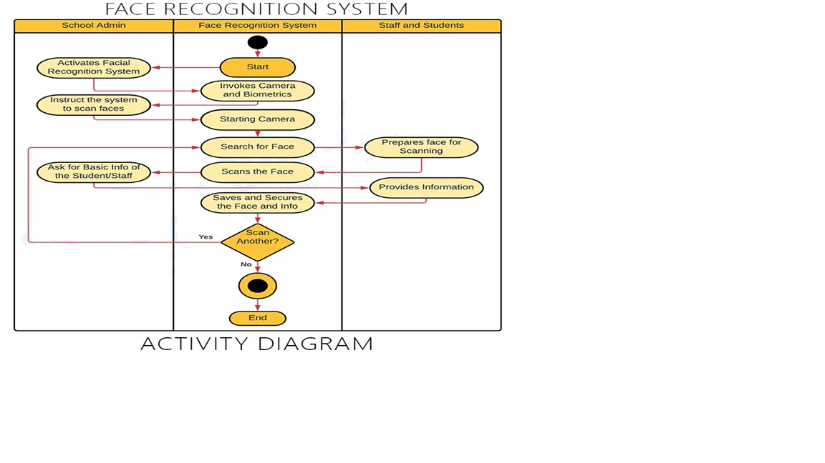

Fig 3: Activity Diagram

# **Results**

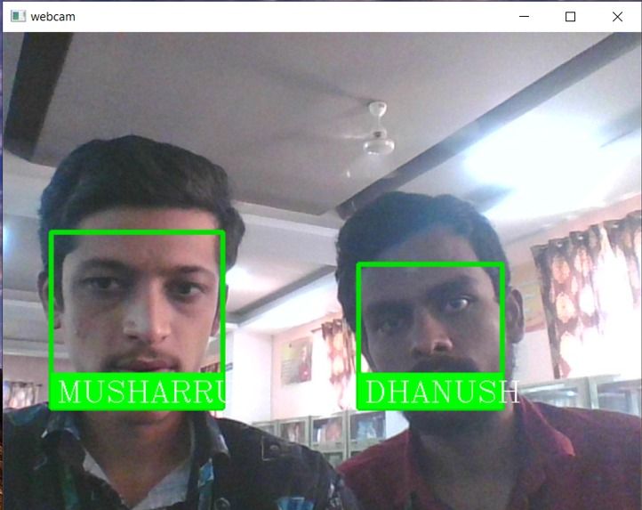

Fig 4: Complete circuit

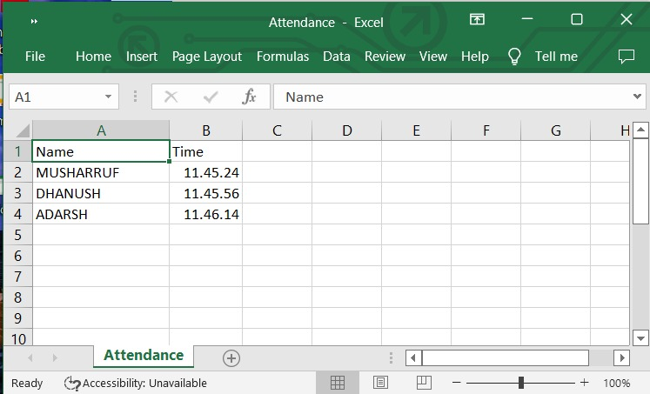

Fig 5: Attendance Marking

# **Conclusion**

The proposed system has a much simpler and efficient algorithm. The system is simpler because of use easy and user-friendly Framework. It has a more efficient algorithm along with much less complex database configurations. The system is more efficient because of being platform independent.

In order to obtain the attendance of individuals and to record the entry and exit, the proposed system can be used. The system can widely be used in the institutions/organizations. The proposed system takes attendance of each student by continuous observation at the entry and exit points. The result of our preliminary experiment shows improved performance in the estimation of the attendance compared to the traditional attendance marking systems.

This system aims to build an effective class attendance system using face recognition techniques. The proposed system will be able to mark the attendance via face Id. It will detect faces via webcam and then recognize the faces. After recognition, it will mark the attendance of the recognized student and update the attendance record.

##### **Acknowledgment**

The satisfaction and euphoria that accompany the successful completion of any task would be incomplete without the mention of people who made it possible, whose constant guidance and encouragement crowned our efforts with success. It is a pleasant aspect that we have now the opportunity to express our gratitude for all of them.

First of all, we would like to express our deep gratitude towards our internal guide **Mrs. RAGINI PATIL, Assistant Professor, Department of CSE** for her support in the completion of our dissertation. We wish to express our sincere thanks to **Dr. E. ANUPRIYA, HOD, Dept. of CSE** and principal **Dr. K. SRINIVAS RAO** for providing the facilities to complete the dissertation.

We are thankful to **Mr. M. RAJASHEKAR REDDY** Secretary of MLR Institute of Technology for accepting us and providing us with an opportunity to do a project in their esteemed organization.

We would like to thank all our faculty and friends for their help and constructive criticism during the project period. Finally, we are very much indebted to our parents for their moral support and encouragement to achieve our goals.

##### **References**

1) Hapani, Smit, et al. "Automated Attendance System Using Image Processing." 2018 Fourth International Conference on Computing Communication Control and Automation (ICCUBEA). IEEE, 2018.

2)Akbar, Md Sajid, et al. "Face Recognition and RFID Verified Attendance System." 2018 International Conference on Computing, Electronics & Communications Engineering (iCCECE). IEEE, 2018.

3) Okokpujie, Kennedy O., et al. "Design and implementation of a student attendance system using iris biometric recognition." 2017 International Conference on Computational Science and Computational Intelligence (CSCI). IEEE, 2017.

4)Rathod, Hemantkumar, et al. "Automated attendance system using machine learning approach." 2017 International Conference on Nascent Technologies in Engineering (ICNTE). IEEE, 2017.

5)Lukas, Samuel, et al. "Student attendance system in classroom using face recognition technique." 2016 International Conference on Information and Communication Technology Convergence (ICTC). IEEE, 2016.

6)https://becominghuman.ai/face-detection-using-opencv-with-haar- cascade-classifiers-941dbb25177

**IEEE conference templates contain guidance text for composing and formatting conference papers. Please ensure that all template text is removed from your conference paper prior to submission to the conference. Failure to remove template text from your paper may result in your paper not being published.**